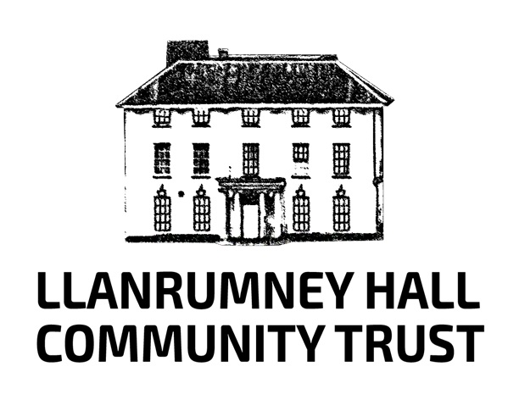

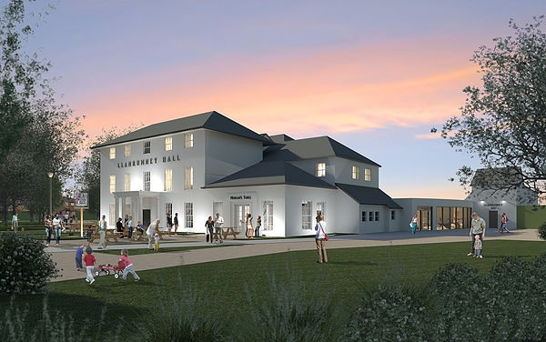

Catering Provision at Llanrumney Hall Tender

January 2019
Tender Document Contents

Section 1 –Introduction

Section 2 –Project Specifications

Section 3 –Tender Application Review Process

Section 1 –Introduction

Llanrumney Hall Community Trust was established in 2016 to steer the regeneration of Llanrumney Hall –a Grade 2 * Listed building with a history dating back to 1452.
The Hall had been left to incrementally decline over many years and required significant remedial work to ensure its future sustainability.
Llanrumney Hall Community Trust became established in 2016 in order to save Llanrumney Hall.
The Trust secured a 35 year Lease agreement with Cardiff City Council and began an inclusive community engagement programme to guide our Business Plan. This reflected the needs and aspirations of the surrounding community and the process and indicative costing to refurbish the building; outline its range of use, and profile projected financial requirements and sustainability for the foreseeable future.
In essence, the local community of over 12500 people requested that Llanrumney Hall, in the heart of the 800+ acre housing estate, be saved for future generations and renovated for use as an inclusive community centre to meet the diverse needs of the population. Llanrumney Hall comprises of 3 floors of rental accommodation of various sized rooms and a large community café area, plus Community Training Kitchen and is situated at the bottom of Ball Road, Llanrumney in the East of Cardiff.
In addition our Trust will site large polytunnels to the rear of the property. One to be used for the exclusive use of the children using the Crèche and After Schools Club activities, and the remaining polytunnels to be used for a Community growing enterprise with fresh produce being provided for use in the Captain Morgan Community Café; any residual produce to be a source of low-cost vegetables and fruit for community use.
The extensive renovation programme began in the autumn of 2017, with Franks and Toms engaged as the Architects and Knox and Wells as the main Contractors for the refurbishment programme.
The Trust anticipates the opening of Llanrumney Hall to be Easter 2019.
A Crèche will provide suitable accommodation for 30-40 children.
The Community Café will provide indoor and outdoor space for circa 80 users.
The kitchen and training kitchen will be designed to offer a range of catering options including larger functions to be catered for, smaller buffet provision and the daily menu options for users of the Café and the requirements of the Tenants who will take rental space in the 3 floors of accommodation at Llanrumney Hall, including the Crèche if required.
The final pages contain the Architects detailed plans for the Ground Floor which includes the Captain Morgan Community Café, kitchen and Community Training Kitchen areas.
We have also included the detailed plans for the other 2 floors of community accommodation which will provide opportunities for Cardiff and Vale College to deliver community education courses and a variety of other users, including new business start up and up-cycling/artistic ranges/community health and wellbeing provision amongst others. The 2 main large ground floor reception rooms can be utilised to host large functions including weddings, birthdays and social event programmes. It is envisaged that there will be developed community events such as Markets and Art and Craft Fayres at the location, together with music, drama and festival activities in the near future. Additionally, the history of Llanrumney Hall lends itself to the development of a tourist experience opportunity.

Section 2 – Project Specifications
Llanrumney Hall Community Trust requires a suitable Contractor(s) to provide a detailed proposal for the operating of the Captain Morgan Café.
Considerations
We are looking for an experienced catering provider that can embrace the context of Llanrumney Hall as a multi-use community centre of excellence.
Alongside providing a café experience of good choice and value for money for users and visitors to Llanrumney Hall, there will be a range of diverse groups and individuals who will want to use the café and associated catering options.
The significant circa £1m refurbishment programme will make Llanrumney Hall an ideal setting for Weddings and other special occasion events. The public who visit our exhibitions and use our wide-ranging and diverse community programmes will anticipate accessing a welcoming café that can accommodate staff, local freelance workers, visitors, community groups and families.
It is important for us to have high quality food on offer that caters for vegans, vegetarians and those with special dietary requirements, alongside café staff with excellent barista skills. Due to our location, we want the café at Llanrumney Hall to be a destination, both for the community regeneration programme of activities where customers might be sitting next to college staff, local physiotherapists, artists or musicians from further afield as well as closer to home, as well as for the amazing and memorable food and coffee that will make them want to return time and again.
Ideally, we are looking for:
- a small to medium catering or food business offering a good quality menu that caters for a range of dietary needs and welcomes community members into the heart of their area;
- a business with a brand ethos that complements that of a shared workspace and community development centre;
- a business owner who would like to work in partnership with us to create a vibrant meeting place and social hub for creative and freelance staff, community education providers, health and wellbeing activity ranges, including a new crèche and after schools activity centre and with a willingness to consider hosting events and activities related to Llanrumney Hall’s development programme;
- a caterer who has the commitment to embrace co-use of the community catering training large kitchen area, use of locally grown produce on site at the venue and co production with agencies such as WRAP –Waste Reduction Action Programme -and their community training programmes such as ‘Love food –Hate waste’.

THE CAFÉ AND SITE
Consumables and crockery are not provided. A list of kitchen equipment and a floor plan can be made available on request.
The cafe has been named The Captain Morgan Community Café in keeping with the history of Llanrumney Hall and has been newly designed and decorated accordingly with Llanrumney Hall and its heritage. Llanrumney Hall itself will be open Monday to Sunday 364 days per year and we envisage the café being operated to maximise servicing the needs of the users and visitors to the location and including special events. There will be outdoor seating areas in addition to the indoor facilities. Full toilet facilities are available within the café and the main entrance provides full accessibility to meet all needs with the provision of a large double opening front doorway.
There is a long term association at Llanrumney Hall with Llanrumney Rugby Club and the café area would continue to be used by the Rugby Club during the season (approximately 20 sessions) from 4pm until 11pm Tuesdays and Fridays and half days on Sundays until 3pm. The Rugby Club will not use the café area on Saturdays and we anticipate the catering company operating the facility will maximise use for weddings and other events taking place at Llanrumney Hall throughout the year.
There is ample parking space for vehicles on site and easy access to the kitchen area for deliveries. The site has 8am to 11pm access Monday to Sunday each week and will be closed only Christmas Day each year. The facility will be locked, fully alarmed with overall CCTV monitoring overnight. The Caretaker lives nearby the site. There is adequate storage space and an office space in situ.

HOW TO MAKE AN EXPRESSION OF INTEREST
Should you wish to visit the site for a tour and an informal conversation about this opportunity, please contact:-
Mary Harris. Development Manager. Llanrumney Hall Community Trust.
E mail: info@llanrumneyhall.org
Tel: 07470044215 or 01 633 681422

We are inviting expressions of interest in this opportunity and ask that you provide a written proposal to include:-
- Your approach to the context of operating Llanrumney Hall’s Captain Morgan Community Café, including any proposals for local volunteering and employment opportunities.
- How you see your business operating in a coordinated approach with Llanrumney Hall Community Trust and how being at The Captain Morgan Community Cafe could support the development of your business and that of the Trust.
- Information on your business and the type of food you are producing or are intending to produce (please include a sample menu and prices);
- A short statement explaining your relevant skills, qualifications and experience and how long you have been trading;
- Submission of 3-5 images of your current operation to demonstrate the visual identity of your brand, if applicable;
- Outline of your income and expenditure forecast for a year ahead.
In addition interested applicants should be aware of the following:-
- The Lease agreement will be for 52 weeks of each year.
- The Catering Operator would agree to abide by the Health and Safety requirements of Llanrumney Hall, including involvement and safe inclusion of Fire Evacuation Drills and the statutory Food Hygiene requirements and governing regulations and recording procedures.
- There are separate toilet facilities for adults and the children using the Café area.

The deadline for Expressions of Interest is 5pm Friday 15th February 2019.

Please email your Expression of Interest or any queries to:-
Mary Harris. Development Manager. Llanrumney Hall Community Trust
E mail: info@llanrumneyhall.org

Section 3 –Tender Application Review Process

Details of the Captain Morgan Community Cafe at Llanrumney Hall becoming available as from Easter 2019 will be placed in the following locations from January 2019:-

- Llanrumney Hall Community Trust main website: www.llanrumneyhall.co.uk
- Llanrumney Hall Twitter: @LlanrumneyHall

- Cardiff Third Sector Council main website: enquiries@c3sc.org.uk

- Development Trust Association Wales website: dtawales.org.uk

Applications will be invited to apply with a closing date of 15th February 2019.

Members of The Board of Trustees of Llanrumney Hall Community Trust supported by an independent catering specialist will review the applications and where necessary and required, invite the person (persons) for interview. All applications should include appropriate references.

We would hope that the final selection would have been completed by the end of February 2019 and the successful applicant notified accordingly.

