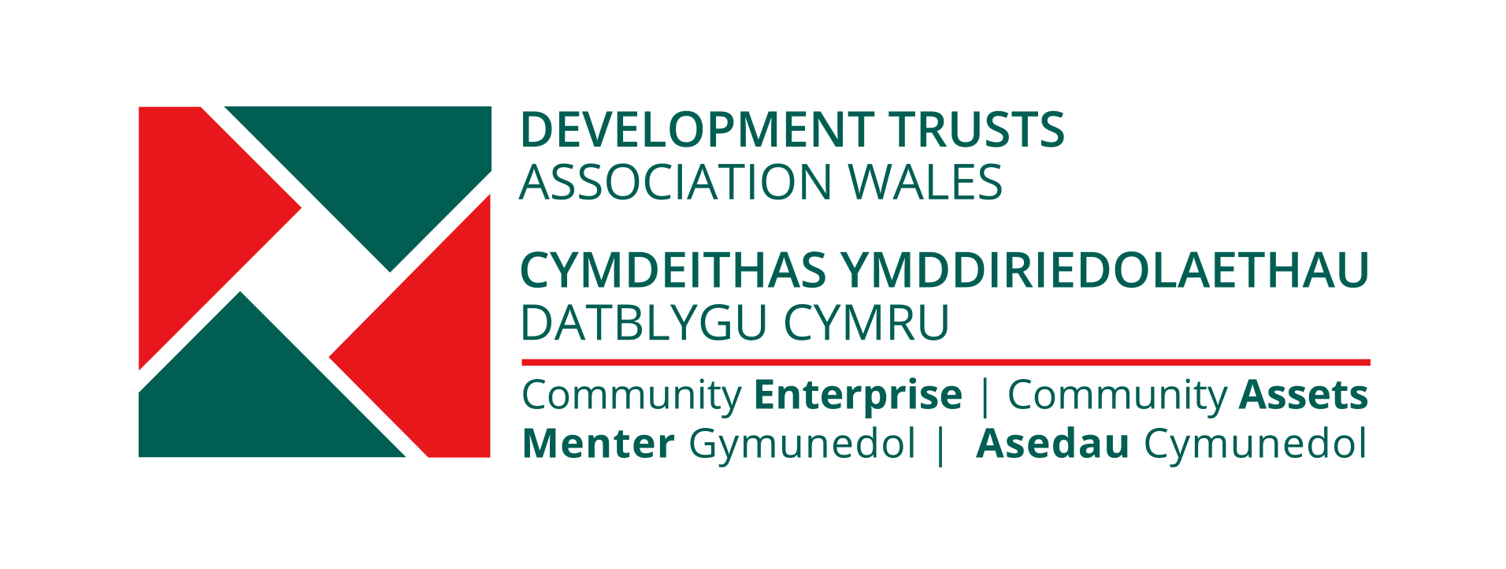

DEVELOPMENT TRUSTS ASSOCIATION WALES
BACKGROUND INFORMATION

THE DEVELOPMENT TRUSTS ASSOCIATION WALES

The Development Trusts Association Wales (DTA Wales) was established in 2003 and is the national, practitioner based membership organisation, supporting and promoting the dynamic networks of community owned development trusts and other community organisations and enterprises in Wales, working together to transform and build sustainable and resilient communities.

We are also part of a wider UK wide movement and network, of more than 1000 community owned enterprises, with DTA Scotland, Locality, in England and DTNI, in Northern Ireland. A number of the development trusts in Wales were original founding members of the UK Development Trusts Association in 1992.

Development Trusts are locally based, community owned organisations, which operate as community enterprises and anchors.

The Development Trusts Association was a response to development trusts and communities who were committed to the long term regeneration and resilience of their neighbourhoods but felt isolated and lacked information of emerging good practice elsewhere. They believed they had a lot to gain from being able to network, learn and exchange knowledge and skills with other practitioners and communities, who shared similar visions and aims and by having a voice at a national level.

DTA WALES SUPPORT AND ROLE

The Development Trusts Association Wales’ role is relevant to, and is a key contributor to, the social and community enterprise, economic development, social, community, climate change and sustainable development agendas in Wales.

DTA Wales provides a range of policy and practice support and advice to its Members, new, emerging and existing development trusts and also to other community owned enterprises, through a number of support programmes and contracts, we manage and deliver (see below).

These programmes are based on peer to peer mentoring, networking and support and knowledge and skills exchange, on a 1 to 1 basis, or online, through action leaning sets, or between community and social enterprises, utilising the practical experience and business skills of our members and best practice, of other community owned enterprises and practitioners, based in communities across Wales and the UK.

This is usually bespoke support, to the needs of the group, community or organisation and could include, as required :- set up advice, organisational and legal forms for SE’s, governance, organisational healthchecks, and other toolkits, funding and investment available, community engagement and capacity building, peer to peer mentoring, best practice case studies and study visits, action learning, knowledge and skills exchange, meetings and events, online and face to face, business and strategic planning and viability, marketing, community asset development and transfer, climate change action and impacts, and energy management and efficiency.

DTA Wales also provides a voice and promotes our members and network and the wider community and social enterprise sector and best practice, at a Policy Level, in Wales and across the UK and internationally. We are also involved in UK policy consultations, briefings, with our sister organisations in the UK, or with others, relevant to our sector, when appropriate.

DTA Wales provides support to its Members and other new, emerging and established community enterprises and organisations developing community owned assets. This has been enabled and made possible by funding from the National Lottery Community Fund Wales and others or through tenders or SLA’s to provide support.

We manage a DTA Wales Pool of DTA staff, locally based third sector and SE coordinators, peer mentors, community enterprise and asset development practitioners and specialist consultants, to deliver support across Wales.

This is across our Peer Mentoring Programmes, including:-

Renew Wales (peer mentoring and support for community action on climate change and the climate emergency in Wales)

Enterprising Solutions (peer to peer mentoring support for new community enterprises)

A Community Asset Transfer (CAT) contract for support and mentoring across Wales, for National Lottery Community Fund CAT funded projects.

Communities Creating Homes (Support for ‘Explore’ stage of new start community led housing projects) in partnership with Wales Cooperative Centre.

A Mentoring support contract, for Social Business Wales new start social enterprise clients, across Wales.

DTA Wales also provides paid for Consultancy Support, to the public sector, support bodies, and individual social enterprise or community organisation clients and has provided support, through several contracts we have delivered, over many years.
On a UK level we are a registered provider to HIVE and a Plunkett Foundation support advisor and have delivered various UK wide programmes, in partnership with Locality and others.

DTA Wales initiated and manages an Energy Action Group, providing advice and quotations on energy costs, supply, and energy efficiency, to third sector organisations and social enterprises, in Wales and across the UK. Current Members of the EAG include DTA Wales, DTA Scotland, Locality, AIM, and Plunkett Foundation networks.

DEVELOPMENT TRUSTS

- Development Trusts are locally based and community accountable and led organisations which operate as social and community enterprises.
- They are involved in trading in goods or services and aiming for financial independence and helping to regenerate and bring and retain ‘assets’ and wealth in our communities.
- Development Trusts are a fast growing network in villages, market or coastal towns, rural areas, former coal mining communities, peripheral housing estates and cities across Wales and the UK with the capacity to make a distinctive and powerful impact in communities which face economic and social exclusion.
- Development Trusts are organisations which are : -
  - Engaged in the economic, environmental, social, and cultural regeneration and resilience of a defined area or community
  - Community based and owned anchor organisations and accountable
  - Aiming for self sufficiency
  - Not for private profit
  - Committed to sustainable development and tackling climate change
  - Independent yet actively involved in partnerships and alliances with and between the community, voluntary, public and private sectors.

DEVELOPMENT TRUSTS NETWORK IN WALES

Development Trusts in Wales and across the UK operate a range of community services and enterprises. Some operate on a small local scale, providing vital community services, managing community development and facilities, or undertaking social, heritage or environmental activities. Others have grown to a larger size, achieving economic, social, cultural and environmental regeneration on a major scale and own, develop and manage a number of community assets and enterprises.

A number manage Community Enterprise Centres or have refurbished derelict or unused buildings, as managed workshop spaces, or have developed Creative and Cultural Enterprise Centres, manage community services, reuse or renewable energy projects, green tourism, climate change, environmental and major events programmes.

Many are central to and responsible for town centre regeneration management, health and wellbeing centres, sports and leisure facilities, shops, community and social facilities, operating significant job and training programmes, building skills and working with excluded groups such as young people or black and ethnic minority communities.

We also have Associate Members, who are not necessarily Development Trusts, but who are part of our movement and support our aims and values and are often partners in our work.

There are development trusts across Wales in urban and rural communities from right across the South Wales Valleys to Cardiff, Swansea, Pembrokeshire in West Wales, Newtown in Mid Wales, Gwynedd, Ynys Mon and Wrexham in North Wales.

OUR VALUES AND PRINCIPLES

The Development Trusts Association Wales and Development Trusts subscribe to key values and principles which include:-

Empowerment – communities must own and control their own future, through their own organisations, enterprises and assets, and community resilience and leadership

Mutuality – only by working together, mutual support, sharing skills and experiences, risks and resources can disadvantaged communities succeed.

Diversity – promoting diversity and equality within our organisations and local communities.

Independence – communities, organisations and activities must be independent of the state and private sector.

Partnership – communities can grow through the strengths of their partnerships, collaborations, and alliances.

Sustainability – development trusts want to help create viable, resilient, and sustainable communities through well managed economic, social, environmental and cultural regeneration. In doing so, they want to minimise or significantly reduce their impact on climate change and the earth’s resources.

If you would like further information about Development Trusts Association Wales, your local development trust, or our services in Wales, please contact:

Development Trusts Association Wales
17 West Bute Street, Cardiff Bay, Cardiff,
CF10 5EP
Tel. 029 20 190260
Email info@dtawales.org.uk
Our Websites and Programme Links
www.dtawales.org.uk
https://renewwales.org.uk
https://dtawales.org.uk/enterprising-solutions
https://dtawales.org.uk/our-work/communities-creating-homes/

