Job Pack – Operations Manager

About DTA Wales
The Development Trusts Association Wales (DTA Wales) is an independent practitioner-based membership organisation promoting the work of, and supporting the growing network of, community enterprises in Wales.

We are a small core team but with an increasingly big reach and growing impact as we work alongside and through our members, a large and growing pool of peer mentors and a range of experienced associates across Wales. Each programme of work we undertake we do through an expanding series of relationships both within Wales and as a Welsh partner across the UK.

With this small core size comes flexibility and an agility to make a real difference here in Wales within this decade, where communities are being challenged through a combination of reduced public investment, increased demand for services, rising costs of living and the challenges arising from the climate and nature emergencies arriving on their doorsteps.

Development trusts are a wide spectrum of organisations – most being geographically located but thematic development trusts are emerging - that are:
- community based, owned and led;
- engaged in the economic, environmental and social regeneration of a defined area or community of place or interest;
- independent but seek to work in partnership with other private, voluntary, and public sector organisations;
- self-sufficient or aiming for self-sufficiency, and not for private profit.

DTA Wales supports their emergence, development and growth through a series of programmes including:

Outreach and engagement amongst communities across Wales, using peer mentoring as the key to encouraging and enabling communities to take the first steps as a development trust. We run the Egin programme on behalf of The National Lottery Community Fund as one example of this.

Enterprise support and development is crucial as communities develop self-sufficient trading models that give them financial independence and long-term viability. We run the peer mentoring and net zero elements of Social Business Wales service on behalf of the Welsh Government.

Community asset ownership support is often if not always key. Communities taking on properties – from shops to village halls, energy generation sites to public green spaces – provides an underlying asset upon which self-sufficient trading can take place. We are the Wales coordinator for the Community Ownership Fund on behalf of the UK Government.

Why work for us?
DTA Wales might be a small team – eight of us in the core with nine facilitators across Wales and adding six new roles this summer - but we hold a series of ‘assets’ of our own that make us a significant force for delivering sustainable and resilient communities across Wales in the coming decade.
- We are independent, answerable to our members who are all themselves community owned enterprises up and down Wales.
- Our members give us our collective intelligence i.e. we draw on their immense skills and experiences in designing and delivering solutions.
- Our members provide us with our front-line workforce i.e. we work wherever possible through a peer mentoring approach where our members are paid to support each other and emergent community enterprises.
- Independence, collective intelligence and access to increasingly professional peer mentors give DTA Wales immense flexibility and an ability to move at the pace and scale required to meet the challenges our communities face.
- We are a hands-on practical solution focused organisation. Occasional forays into policy development don’t get in the way of building a groundswell of community enterprises helping communities become sustainable and resilient across Wales through practical action whether that be in the social services, the arts, sports, local food and transport or the environment.

DTA Wales has the potential to be a small team with a big reach into communities across Wales. Through the power of community action DTA Wales plans to play a transformative role in how Wales achieves a more sustainable economy, society and environment. By consistently cooperating with others DTA Wales’s member’s influence and impact is amplified.

By joining DTA Wales you will become part of that small core team but will have the chance to affect big change. People work for us if they understand the big strategic needs for achieving a sustainable economy but believe in the power of enabling community. An interest in policy is welcome, but a passion for practical action is paramount.

If you fancy the challenge and the opportunity, apply to work with us.

About this position and the programme you will support.
This is a key role for the DTA as we expand rapidly during 2023 from a core team of seven to a team thirteen restructured into three delivery teams (see page 1). As we continue to grow and open up increasingly exciting opportunities to work with our members in Wales and to become the Welsh collaborator in UK-wide programmes we are seeking an experienced and ambitious Operations Manager.

Working in direct partnership with the CEO and alongside our Financial Manager this role plays two pivotal roles for DTA Wales. Internally it will help us further develop the operational foundations - our systems and procedures - that allow our Heads of Departments to deliver their services with increasing professionalism. Externally it will play an active role in helping us design new projects and programmes with increased efficiency and impact.

Job Description

 | Job title: | Operations Manager
 | Managed by: | CEO
 | Managing: | Administration Team.
 | Key relationships: | Direct engagement across Senior Management Team and close liaison with the new Mentoring and Membership Officer.
 | Pay rate | £44,000 (FTE)
 | Days per week | 0.6 FTE (3 days a week) - we are very happy to discuss extended or reduced working hours to suit individual circumstances.
 | Term of employment | Permanent
 | Hours of work | 7 hours per day. DTA Wales sets core office hours as between 10am and 4pm but offers flexibility by negotiation with line managers. Occasional working at evenings and over weekends may be required to meet the needs of the role.
 | Job location | DTA Wales retains a Cardiff office. Home working - or supported to work from 'local to you office hub' - anywhere within Wales or within easy reach of Wales is supported.
 | Travel expectations (work base) | We retain the expectation for you to be in a DTA office and part of a DTA team on a reasonable basis.
 | Travel expectations (role delivery) | Travel around Wales (and occasionally elsewhere in the UK) is occasionally expected as part of this role.
 | Summary of role | DTA Wales is a small team but with increasingly big reach and impact. As we grow and add staff and services we require an experienced Operations Manager to lead the reformation of systems and procedures within DTA Wales and to actively engage in how we operationally design and bring on board new projects and programmes.
 |  | You will hold a central role in helping DTA Wales consolidate its foundations that will in turn underpin our ability to increase our impact in the future.
 | Roles / responsibilities | Bring together, consolidate and lead the core administration team within DTA Wales that supports and enables our on-the-ground operations.
 |  | Actively collaborate with the senior management team to ensure the design of, and compliance with, operational systems that meet the needs of our plans for growth.
 |  | Specific support to the new Mentoring and Membership Officer in ensuring our obligations and systems for engaging with our members are fit for purpose.
 |  | Review and refresh DTA Wales policies and procedures to ensure they meet our plans for growth.
 |  | Identify and recruit - where not already in place -external operational support in areas such as HR, data management, legal, ICT etc. to ensure we remain a small but well supported core team.
 |  | Provide - or coordinate access to - HR support to Heads or Service and take a lead on improving DTA Wales's performance in areas such as Fair Pay and Investors in People.
 |  | Working with our Finance Manager to ensure appropriate financial information is provided to Heads of Services in a timely manner.
 |  | Actively engage - alongside Heads of Services - in the operational design of the forthcoming projects and programmes.
 |  | Review how DTA Wales functions as a remote working team including optimising the future role of our Cardiff office base. Including if appropriate taking on the management of the office.
 | Person specification
 | Essential
 |  | Welsh speaking or a confirmed willingness to undertake learning.
 |  | Demonstrable experience in operational administration & management and systems development (can be from any sector).
 |  | Substantial experience in at least one of the following areas: human resources, financial management, data management, software systems, office management, project / programme management.
 |  | Proven aptitude for problem solving.
 |  | High standard of computer literacy with experience of some relevant software support packages.
 |  | Self-starter and ability for independent working alongside being a strong team player.
 |  | Experience of the design and implementation of administrative systems.
 |  | Strong attention to detail and proven adherence to deadlines.
 |  | Excellent written and numeric reporting skills.
 | Desirable | Proven track record of team building and leadership.
 |  | Knowledge or understanding of the social enterprise and community development sector.
 |  | Project management experience.
 | KEY DATES
Closing date for applications |  |  | Thursday 13th July - 5pm
Shortlisting |  |  | Friday 14th July
Interview / selection day |  |  | Wednesday 19th July – please place this as a marker in your diary.
Anticipated start date |  |  | As soon as possible.

Where you will sit within DTA Wales.

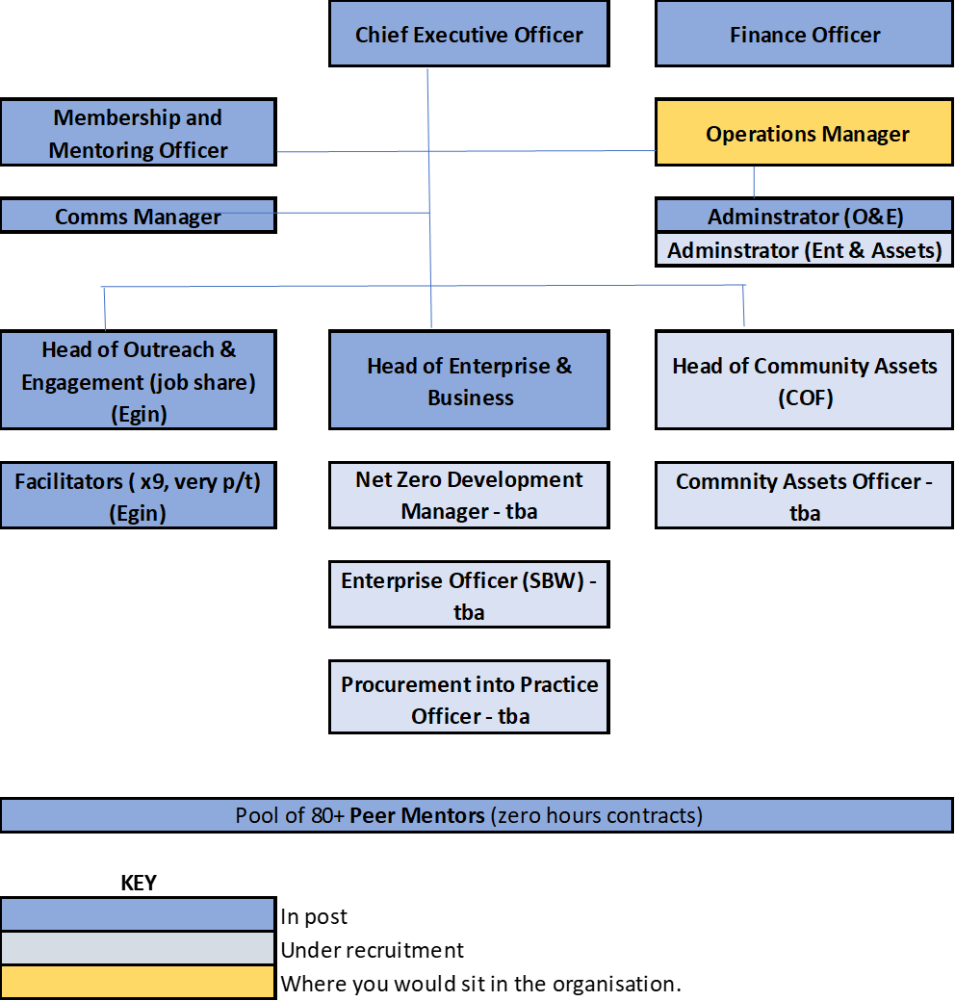

How to apply.
Please complete the application form and return it to info@dtawales.org.uk, with the job title in the subject line.

Please also complete an Equal Opportunities Monitoring Form: https://forms.gle/E1WUWEsjNNSaYDQV9
The Equal Opportunities Monitoring form is anonymous and will not be included as part of the shortlisting process. All provided information will be used for recruitment monitoring and provision of statistical data purposes only.

Development Trusts Association Wales, 17 West Bute Street, Cardiff CF10 5EP
Cymdeithas Ymddiriedolaethau Datblygu Cymru, 17 Stryd Gorllewin Bute, Caerdydd CF10 5EP Tel/Ffôn 029 2019 0260 Email/E-bost info@dtawales.org.uk Website/Gwefan www.dtawales.org.uk
Company registration no./Rhif cofrestru’r cwmni 04966246

